02 - Parallel, Radial and Spiral, Finishing Strategies.

Introduction.
This chapter will cover Finishing strategies created by the downward projection of a pattern, which include four types, Parallel, Radial and Spiral.

FeatureCAM generates toolpaths by projecting a pre-defined strategy down the Z-axis onto the model. The standardised geometry for Parallel, Radial, and Spiral are generated by entering values into the Finishing Form. The resultant pattern can be displayed by selecting Preview before executing the command by selecting Apply

A Preview of the three pattern strategies are shown, looking down the Z.

Parallel Radial
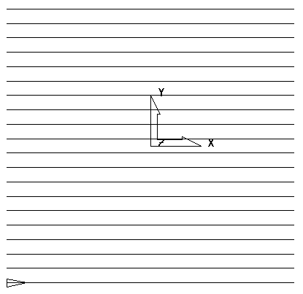
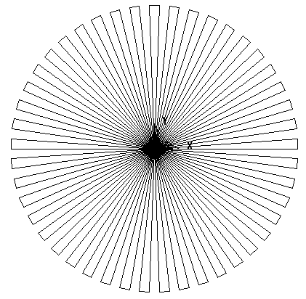

Spiral

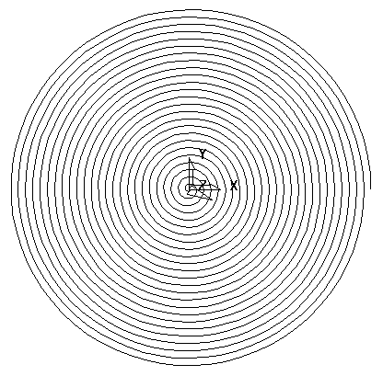

Parallel Example

- Create a new millimeter milling document.
- Press Finish on the Dimensions form.
- From the main menu select File > Import.
- Select the model Chamber2.igs and press Open.
- Check Use the wizard to establish the initial location and stock size.
- Press Finish and select an Isometric view.

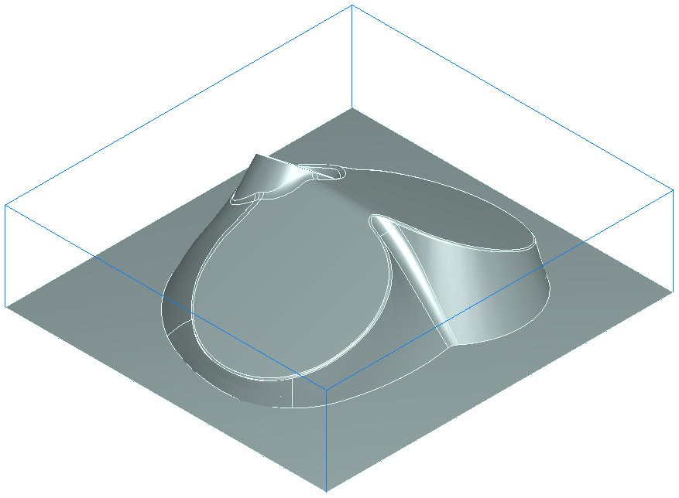

The part has now been imported and the stock size set. We will now generate a Parallel finishing toolpath. This strategy will finish the part by making a series of parallel passes across the job at a user defined angle. Parallel finishing is also known as Raster finishing.

- In the Step view select Features.
- On the New Feature form select Surface finishing and press Next.
- Box select all of the surfaces and press the Add from selected items button then press Next.
- On the New Strategy form check Choose a single operation.
- Press Next.
- On the next form check Parallel.
- Press Finish.

The Parallel machining operation has now been set up using the default settings. We will now simulate the machining operation before further refining it.

- From the Simulation toolbar select the Centerline simulation button
- Press the Play button

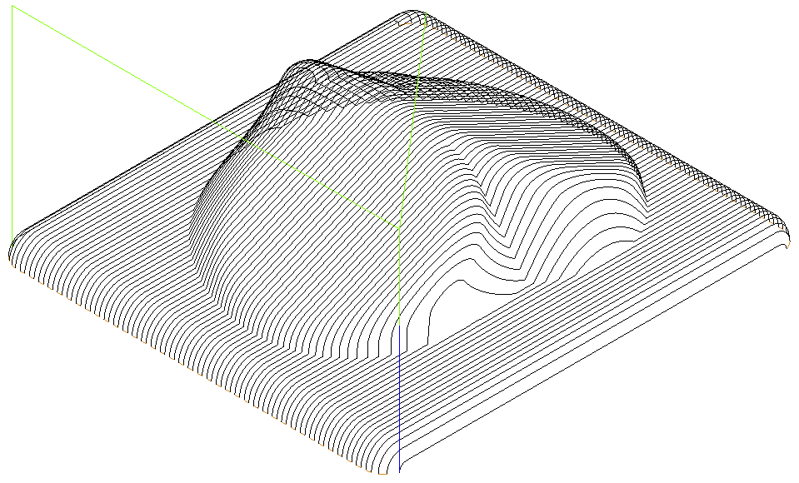

The toolpath should appear as shown above. It can be seen that the cutter is rolling over the edge of the part and the surface finish in steep areas parallel to the cutting direction is poor. We will now modify the cutting strategy to resolve these problems.

- In the Part view double click on srf_mill 1.
- Click on Parallel in the tree view.
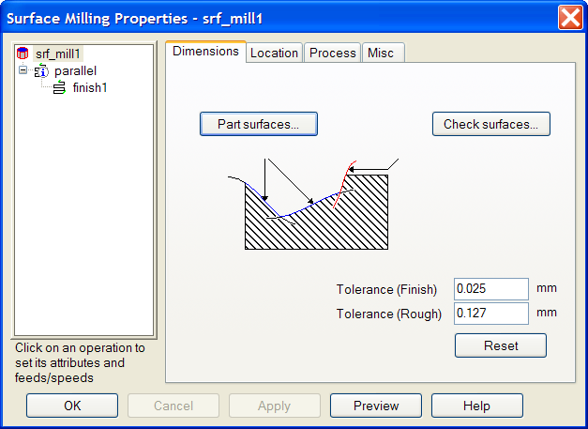

- Check Internal only and Add perp. remach. Pass.

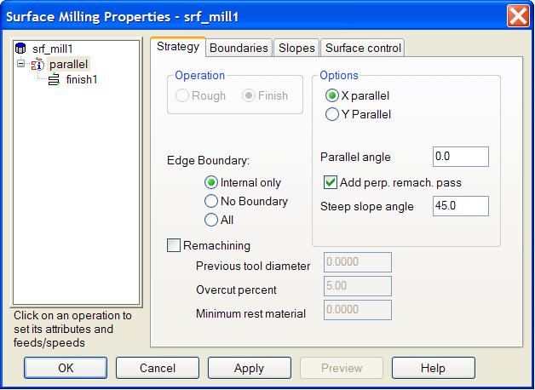

- Run a Centerline simulation as before.

The toolpath is now constrained so that it does not roll over the edge of the part. Note how the area that was poorly finished previously has been re-machined with a perpendicular pass to give an improved surface finish.

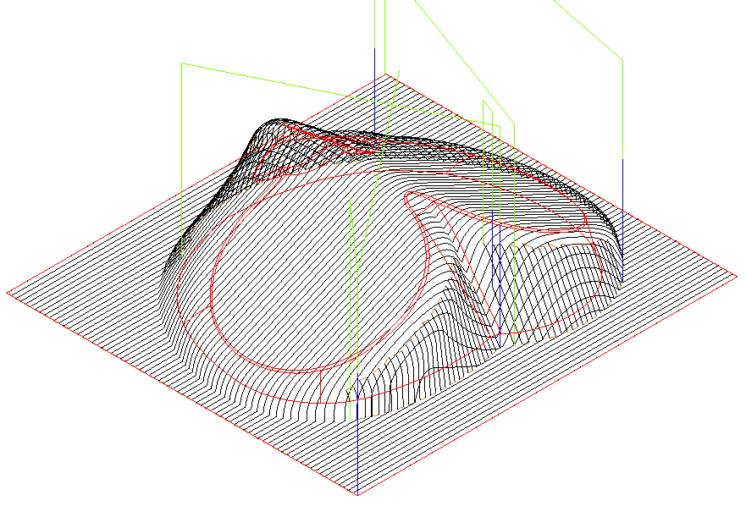

The toolpath can be further modified by changing the way in which the tool steps over between passes. In this case we will cause the tool to loop smoothly between passes.
The stepover will be increased and a material allowance added to create a semi-finishing toolpath.
- Edit the Feature (double click on srf_mill 1 in the Parts view).
- Click on finish 1
- Select the Milling tab.
- Click on Stepover.
- Enter the New Value of 3.0mm
- Press Set.
- Click on Leave allowance.
- Enter the New Value of 0.5mm
- Press Set and then Apply.
- Click on the Leads tab.
- Change the Stepover type to Loop.
- Press Apply.
- Click on Parallel in the tree view
- Uncheck Add perp. remach. pass.
- Press Apply and then OK.
- Run a Centerline simulation.

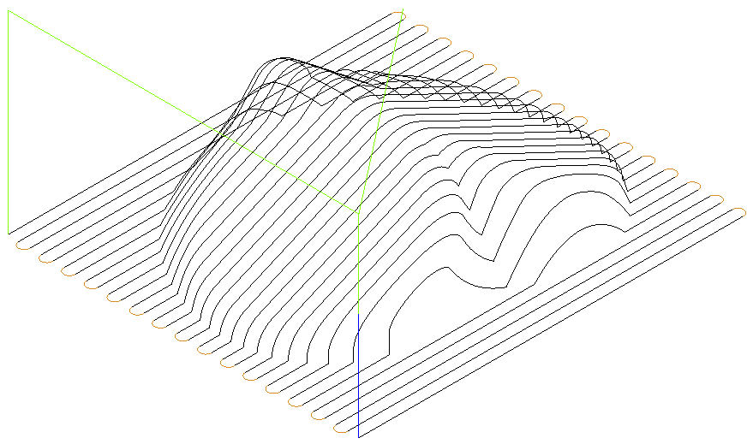

The tools is now looping on and off the job smoothly, note the larger stepover.

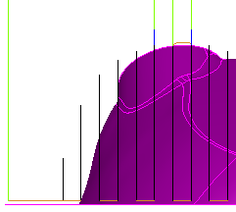
- Select a view from the Front.

Note how the toolpath is now leaving the required finishing allowance on the job.

- Close the Part.

Radial Machining

Radial machining is useful for machining round parts. In this strategy the tool moves in and out radially on the part, stepping over between passes by a specified angle.

- Create a new millimeter milling document.
- Press Finish on the Dimensions form.
- From the main menu select File > Import.
- Select the model Radial.x_t and press Open.
- Check Use the wizard to establish the initial location and stock size.
- Press Next three times.
- Check Round and Z Axis.
- Press Next twice.
- Fill in the form exactly as shown below.

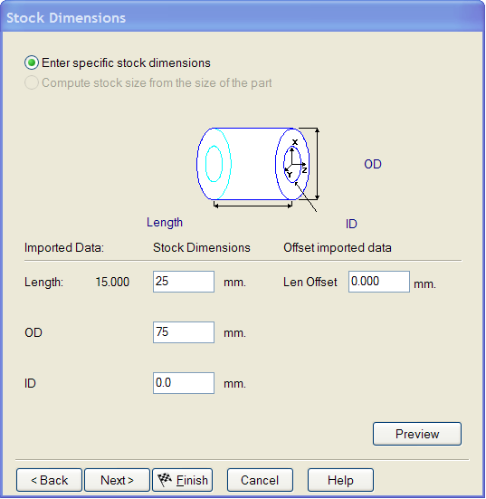
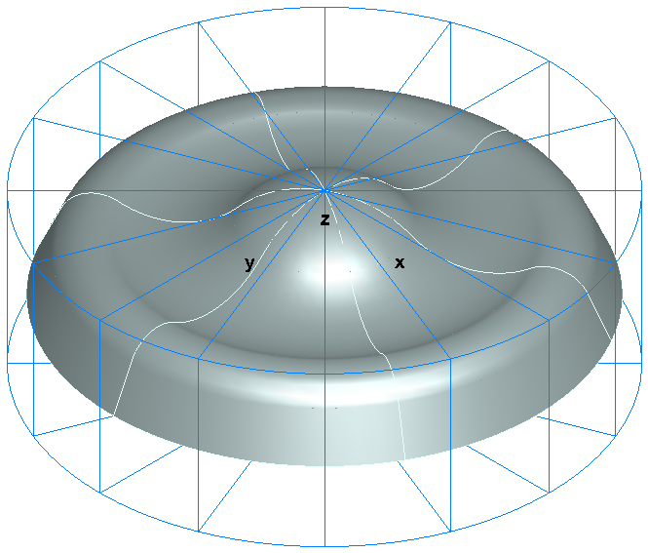

- Press Finish
- Select an Isometric view.

The part and stock should now appear as shown on the left. Having set up the part and stock we can now generate a radial finish machining operation.

- In the Step view select Features.
- On the New feature form select Surface milling and then Next.
- Box select all of the surfaces and press the Add from selected items button then press Next.
- On the New Strategy form check Choose a single operation.
- Press Next.
- On the next form check Radial.
- Press Finish.
- Edit the Feature.
- Click on radial in the tree view.
- Click on the Strategy tab and check Internal only.
- Click on finish 1 in the tree view.
- Select the Milling tab.
- Click on Center point.
- Enter the New value as pt(0,0,0) and press Set then Apply and OK.
(This is setting the center point of the radial pattern to be at the XYZ origin).
- Run a Centerline simulation.

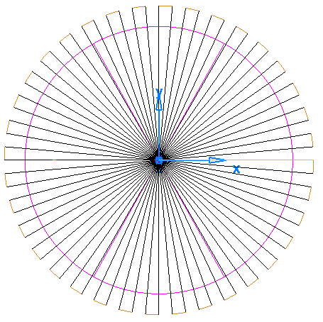

It can be seen that the toolpaths are too close together at the center of the part and far apart towards the edge.

We will now modify the toolpath so that it has a more suitable stepover. The center of the part will not be machined, a different strategy will be used for this area later.

- Edit the Feature.
- Click on finish 1 in the tree view.
- Click on the Milling tab.
- Click on Radius end and set the value to 25
- Click on Radius start and set the value to 75
- Click on Stepover angle and set the value to 1
- Press Apply and then OK.

- Run a Centerline simulation.

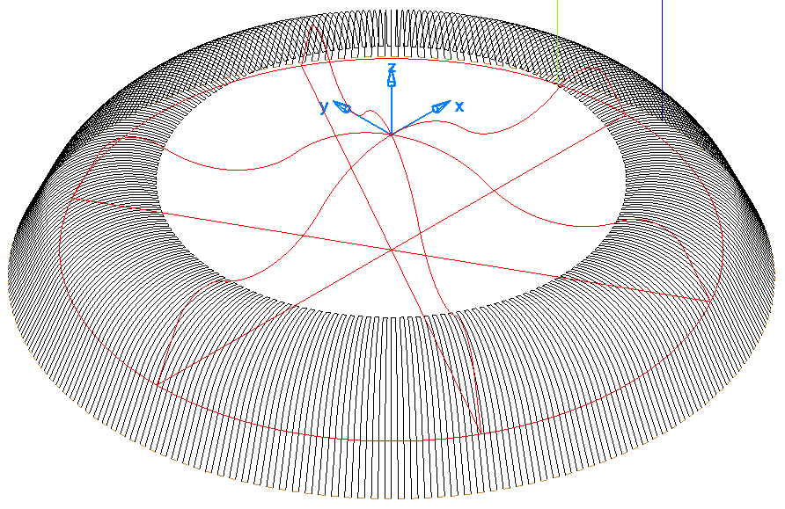
The stepover is now finer and varies less. The user also has control over the angle through which the toolpath sweeps and the direction. We will now make a single direction tool path which machines from inside to out through a specified start and end angle angle.

- Make a copy of the Feature.
- Uncheck srf_mill 1 in the part view.
- Edit the new Feature.
- Click on finish 1 in the feature tree.
- Select the Milling tab.
- Click on Angle start and set it to 0
- Click on Angle end and set it to 180
- Click on Direction and change to Unidirectional.
- Press Apply and then OK.
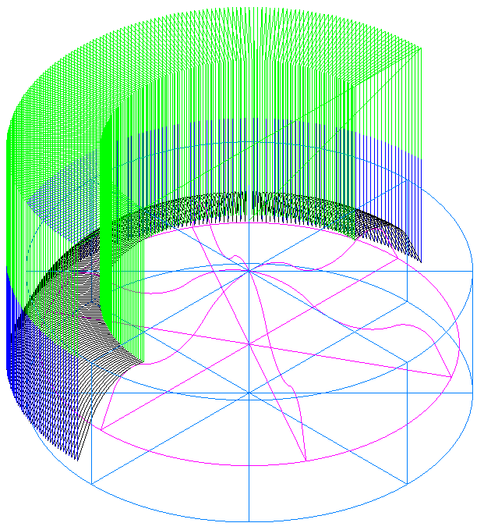
- Run a Centerline simulation.

The toolpath starts on the X axis (0) and goes in an anticlockwise direction until it meets the negative X axis (180).

- Edit the Feature.
- Click on finish 1 in the feature tree.
- Select the Milling tab.
- Click on Angle start and set it to 180
- Click on Angle end and set it to 0
- Press Apply and then OK.
- Run a Centerline simulation.

The toolpath will now run in the opposite direction, starting on the negative X axis and ending on the positive X axis.

- Delete the new Feature.

Spiral Machining

Spiral machining allows the user to finish a part using a single spiral pass. The direction may be clockwise or counter clockwise and may work from the outside inwards or from the inside outwards. We will now machine the remaining part of the model using a spiral strategy. In order to control the toolpath overlap we will use a circle as a boundary. If a boundary is not used the spiral toolpath will machine the entire part.

- Create a geometry circle Radius 26 at 0,0,0
- Edit the Feature.
- Click on srf_mill 1 then the Process tab.
- Click on the Add new operation button.
- Select 2D Spiral.
- Click on spiral in the tree view.
- Select the Boundaries tab & check Use a curve as boundary.
- Click on Curve Options.
- Check 3D Pocket.
- Click on the Boundaries button then the Pick Curve button
- Select the circle then press OK.
- Press OK.
- Select the Strategy tab.
- Check Internal only and Inside out.
- Press Apply.
- Click on finish 2 in the tree view.
- Select the Milling tab.
- Set the Stepover to be 0.5mm.
- Click on the Direction button and select clockwise then press OK.
- Press Apply and then OK.

- Run a Centerline simulation.

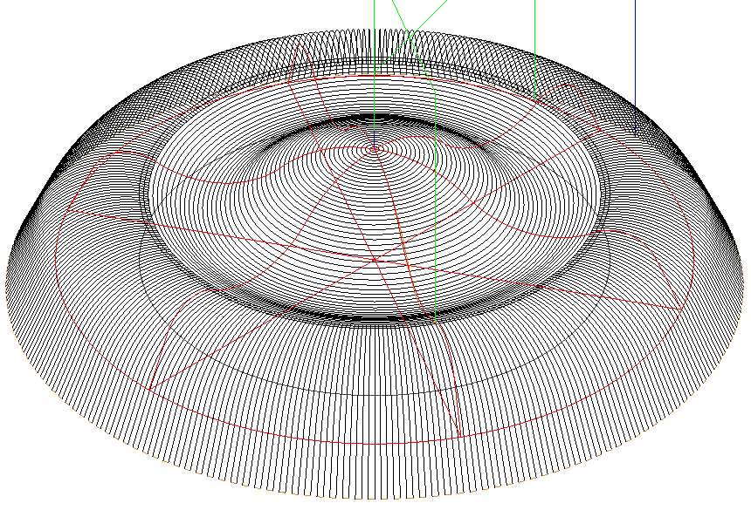

The completed machining process.

